**Java NOTES**

1. Array declaration in Java

- arrays in JAVA are objects

- arrays are dynamically allocated

- arrays size cannot be changed

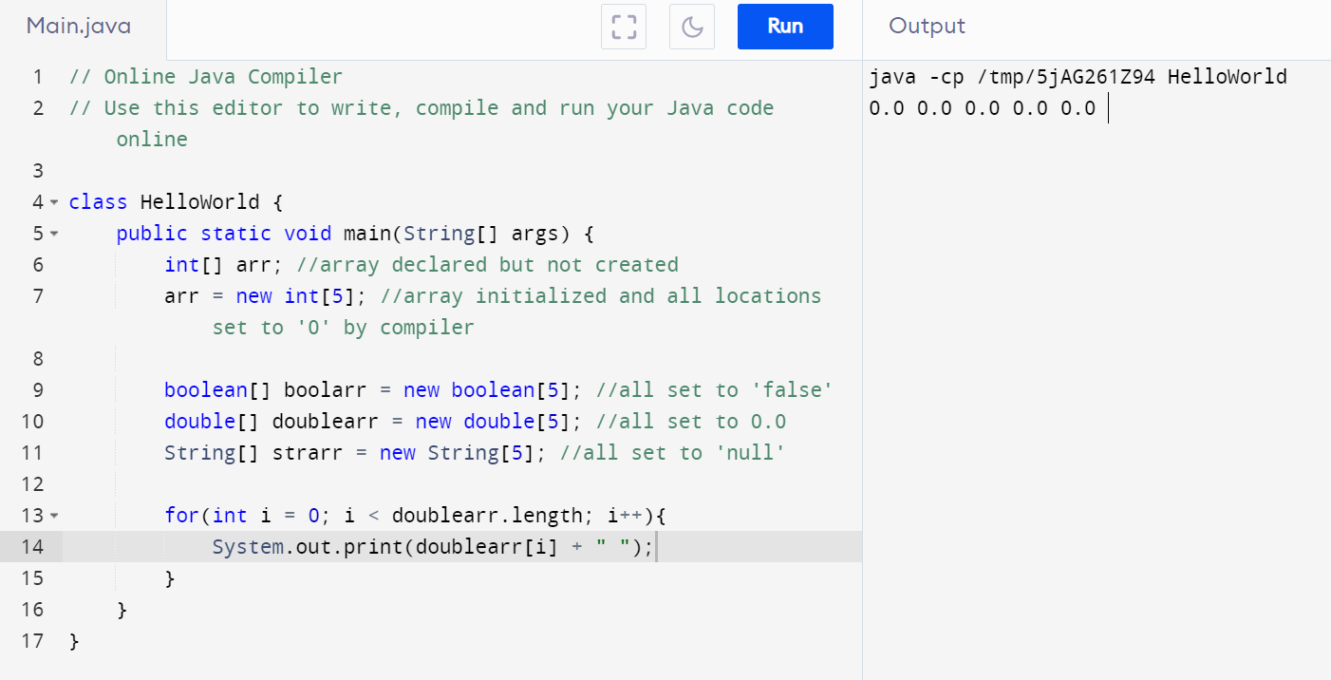

2. Initializing array

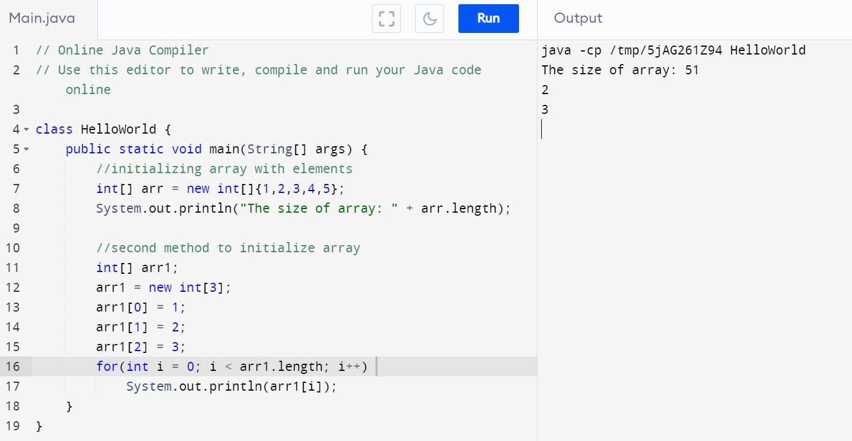

3.